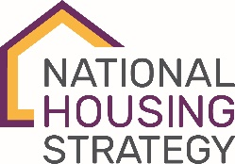

PERFORMANCE MEASUREMENT
FRAMEWORK (PMF) TEMPLATE

(DEMO OUTCOME 001)
Innovative solutions that support the NHS priority areas and/or populations and outcomes are showcased in affordable housing projects, assessed and disseminated so that others can replicate
001.1 NHS Results/Impacts.  See application form section 4.2 | [Insert elements from application form section 4.2]
001.2 Case studies are made available that highlight significant NHS projects.
001.3 Percentage and type of participants who would consider implementing innovations in their own projects.
001.4 Number of knowledge transfer activities/products available for consultation, with scope of availability (regional/national/other).

(DEMO OUTCOME 002)
Information and tools demonstrating how to implement and/or replicate innovative solutions for the affordable housing sector are increased
002.1 Number of housing stakeholders who participated
in or accessed knowledge transfer and capacity-building activities.
002.2 Number and type of housing stakeholders engaged
in scaling-related activities following their participation
in demonstrations activities.

(DEMO OUTCOME 003)
Business, community and stakeholder collaboration opportunities are developed
003.1 Number of partnerships implemented through
the demonstrations.
003.2 List of partnerships outcomes in terms of collaboration.

